Instructions and additional accessories

**Syringe pump accessories:**

1. Power supply (Brand: Mean Well, NES-150-12)
   1. Input:
      1. 100-120 VAC 3.0 A
      2. 200-240 VAC 2.0 A
   2. Output: +12V 12.5 A
2. Rainbow wires

* The Ground side (-) on Big Easy Driver go to the (-) port of power supply.
* The (+) on Big Easy Driver side go to the (+) port of power supply.

1. Fuses (Little fuse Inc)

* Fuses are connected onto the (+) end of the wire. We have used 0.5 A or 1 A fuses.
* Fuses act as safety devices that they break when unusually high currents pass through.

1. Fuse holders (Little fuse Inc)

**Safety concerns:**

* Wrong wire connections would result short circuit and fire accidents.
* The white trimmer screw on the Big Easy driver controls the gain of the stepper motor controller. When you first connect the stepper motor, turn it all the way down (counterclockwise), then slowly turn it up until the motor starts working. If it’s set too high, the motor will overheat.

**Tools needed to make the syringes pumps:**

1. Soldering kit
2. Headers
3. Pin header strip (OdiySurveil)
4. Tool box( wire cutters, wire strippers, screwdrivers… etc)

**Syringe pumps cookbook:**

1. Print all the syringe pump parts with a 3D printer. These STL files were tested with the Formlabs Form2 printer.
2. Test your stepper motor first:

* Make the Big Easy Driver board (solder the header pins on the required places).

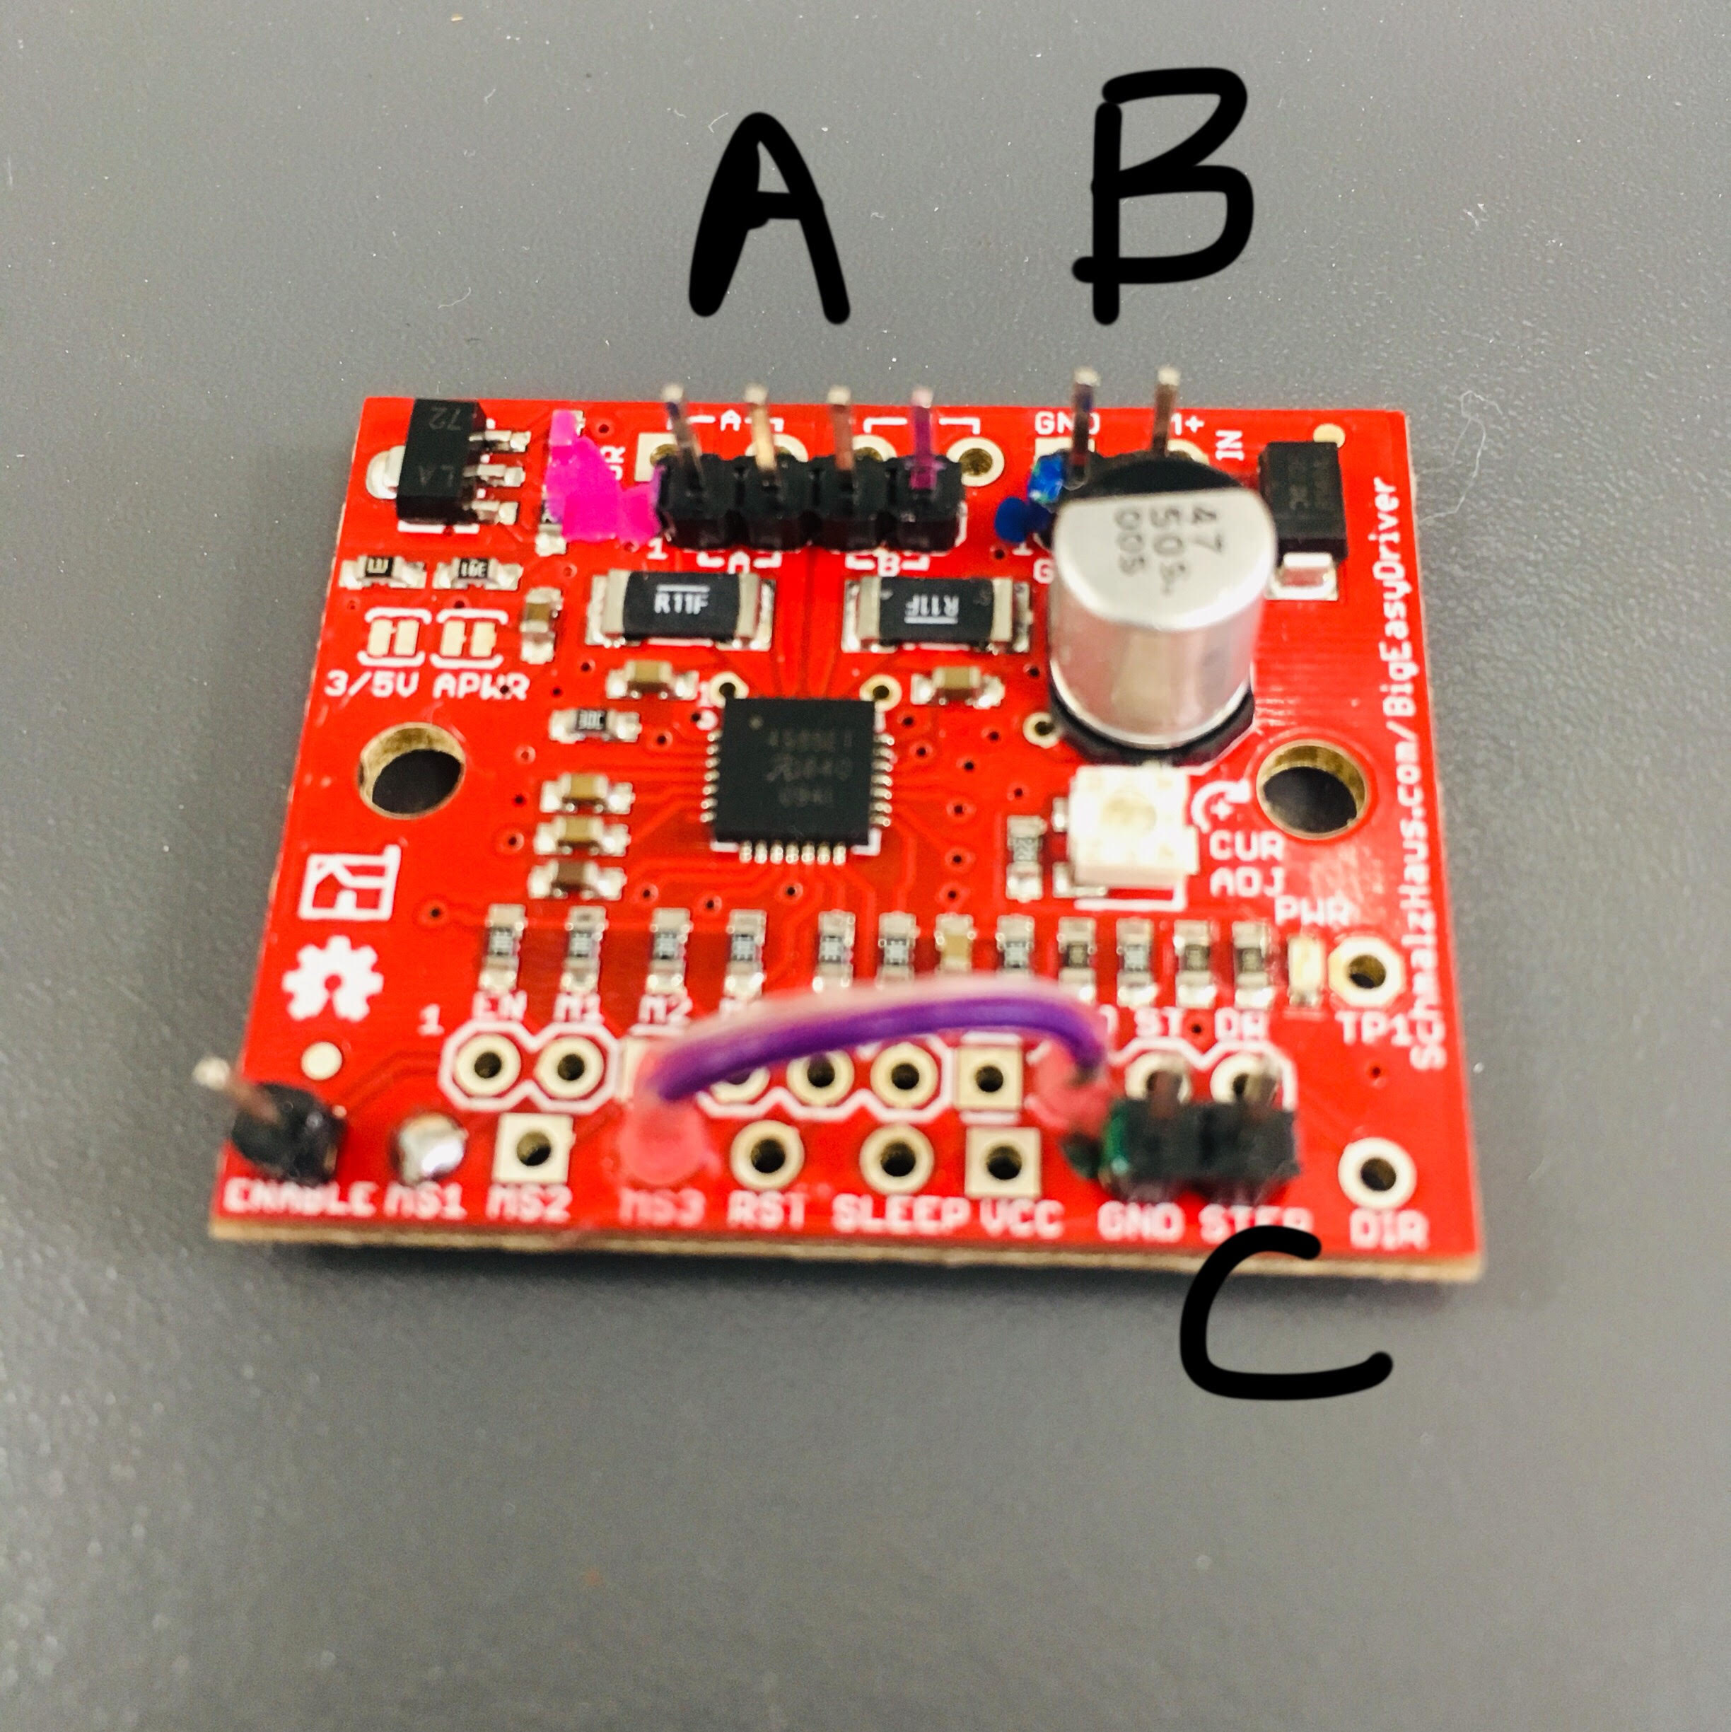

* + Install a 4-pin header on the [A][B] pin holes (A as picture shown).
  + Install a 2-pin header on the [ground] [M+] pin holes (B).
  + Install a 2-pin header on the [GND][STEP] pin holes (C).
  + Conenct [GND], [MS3] and [MS1] pin holes with a piece of wire (below). It is important that the wire does NOT touch [MS2].

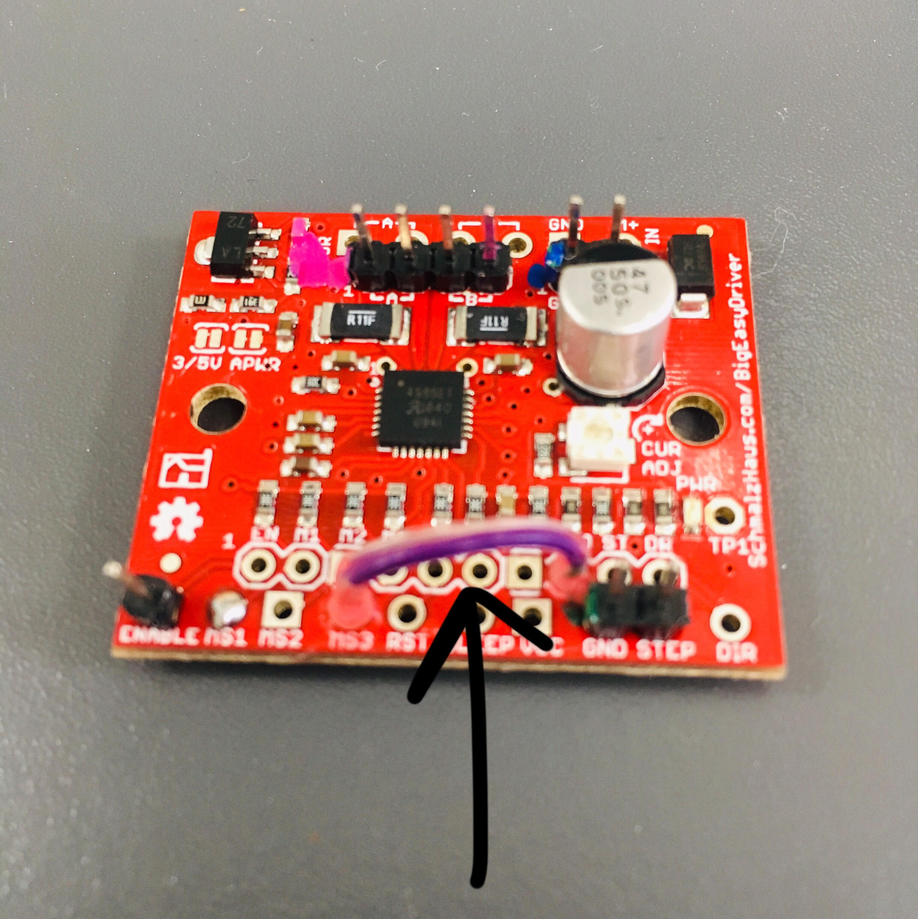

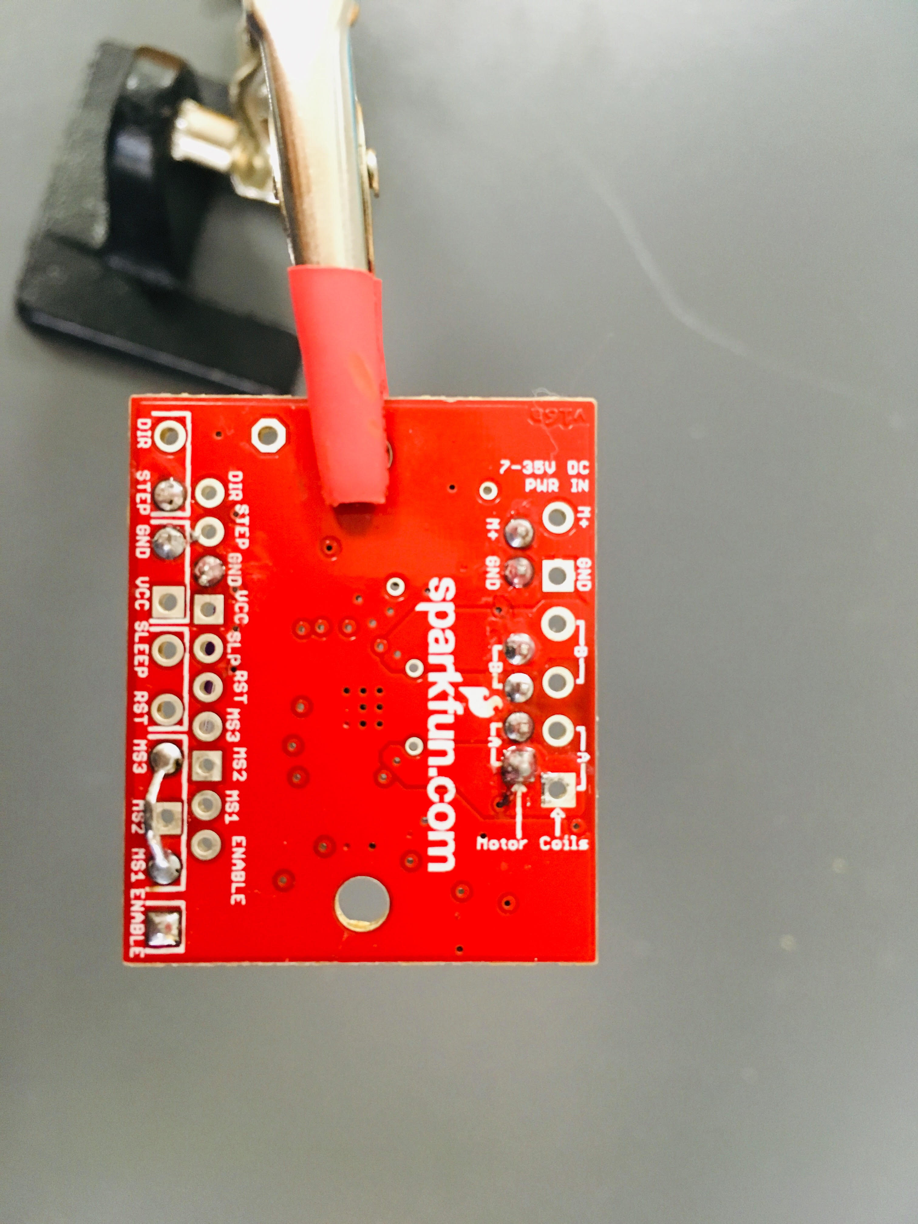

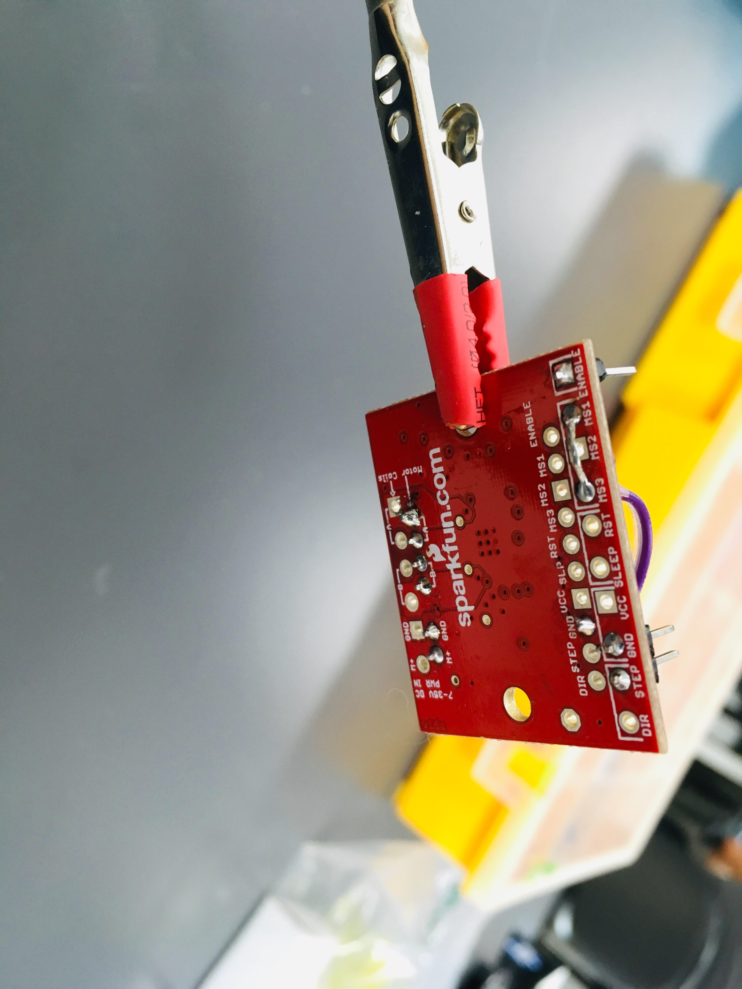

* + - This is to control the number/direction of the motor turn on certain degrees.
* Solder a 4-pin header on the wires of the stepper motor (wire color sequence matters! Black, Green, Red, Blue)

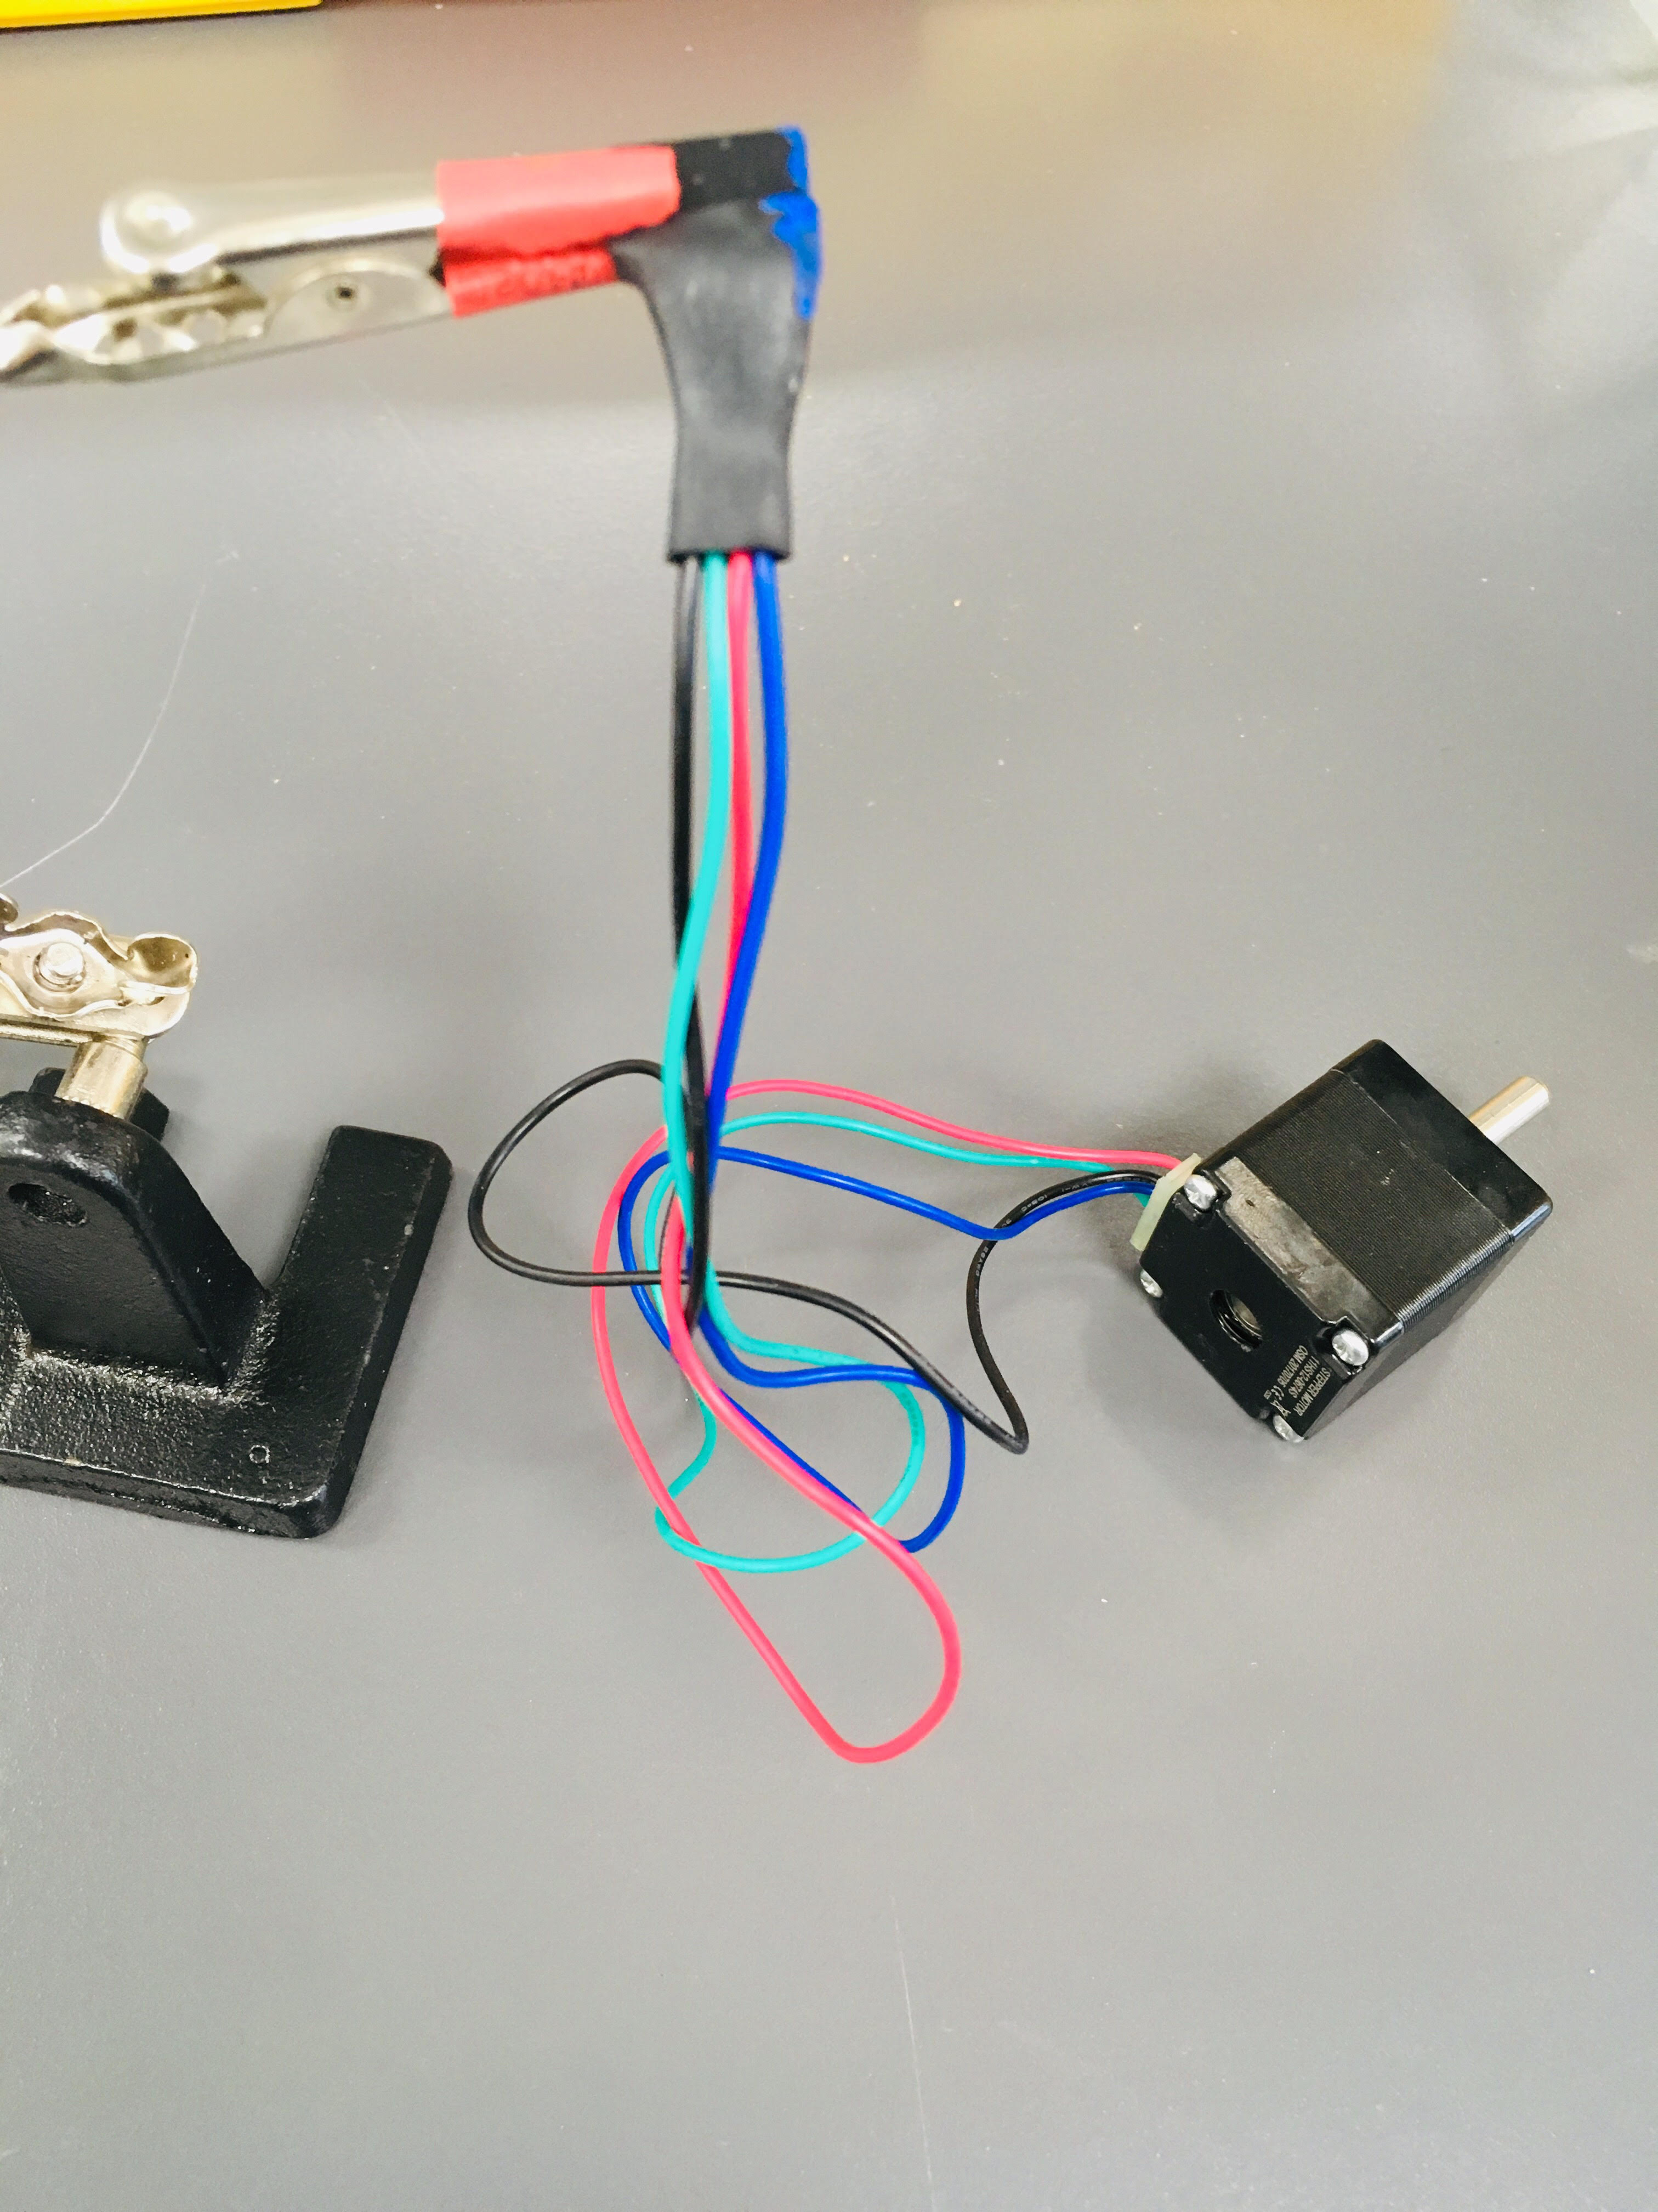

* Connect the stepper motor to the 4 pins on the Big Easy Driver.
* Connect the power supply pin ( [ground] [M+] pins) on the Big Easy Driver board to the power supply with wires.
* Turn on the power supply to see if the pole turns.

Assemble the threadkeys. Use a hammer to insert the BlankToolHolder into the 300threadKey. Tap the hole with an M5 tap, then use a hammer and screwdriver to remove the BlankToolHolder. Durable or Tough resins are probably best for the threadkey, as the main failure point of this syringe pump design would likely be the threads on the threadkey becoming stripped.

Assemble all the 3D-printed parts together (including the stepper motor).

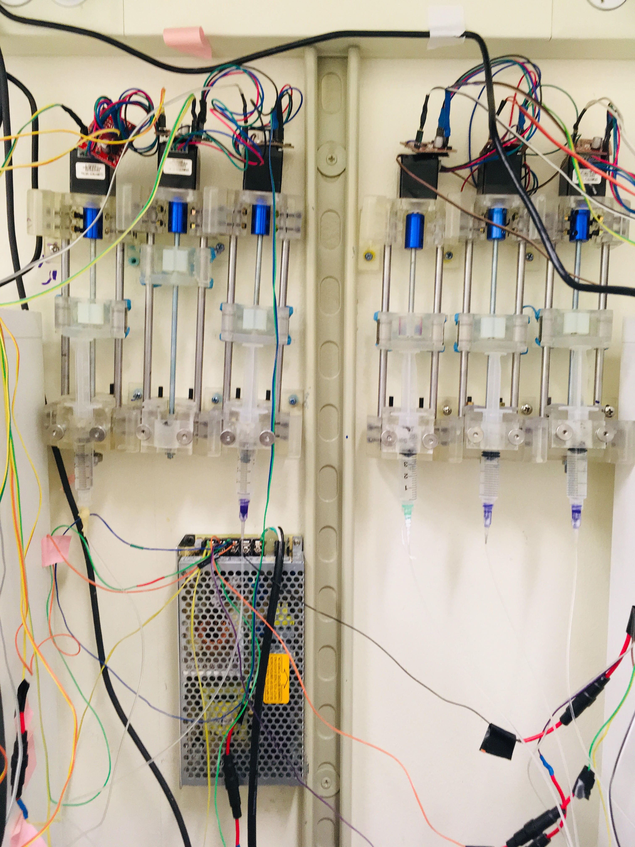

1. Put the fuses in the fuse holders soldered onto your power supply wires.
2. Connect the Big Easy Driver to the Arduino board with wires via pins [GND][STEP].
3. Download the Arduino program on desktop.
4. Control your syringe pumps.

* Go on GitHub -> Sjulson Lab-> behavior_box-> DUE_greenStandard_v7 to get the latest arduino code.